DISCUSSION GUIDE
For

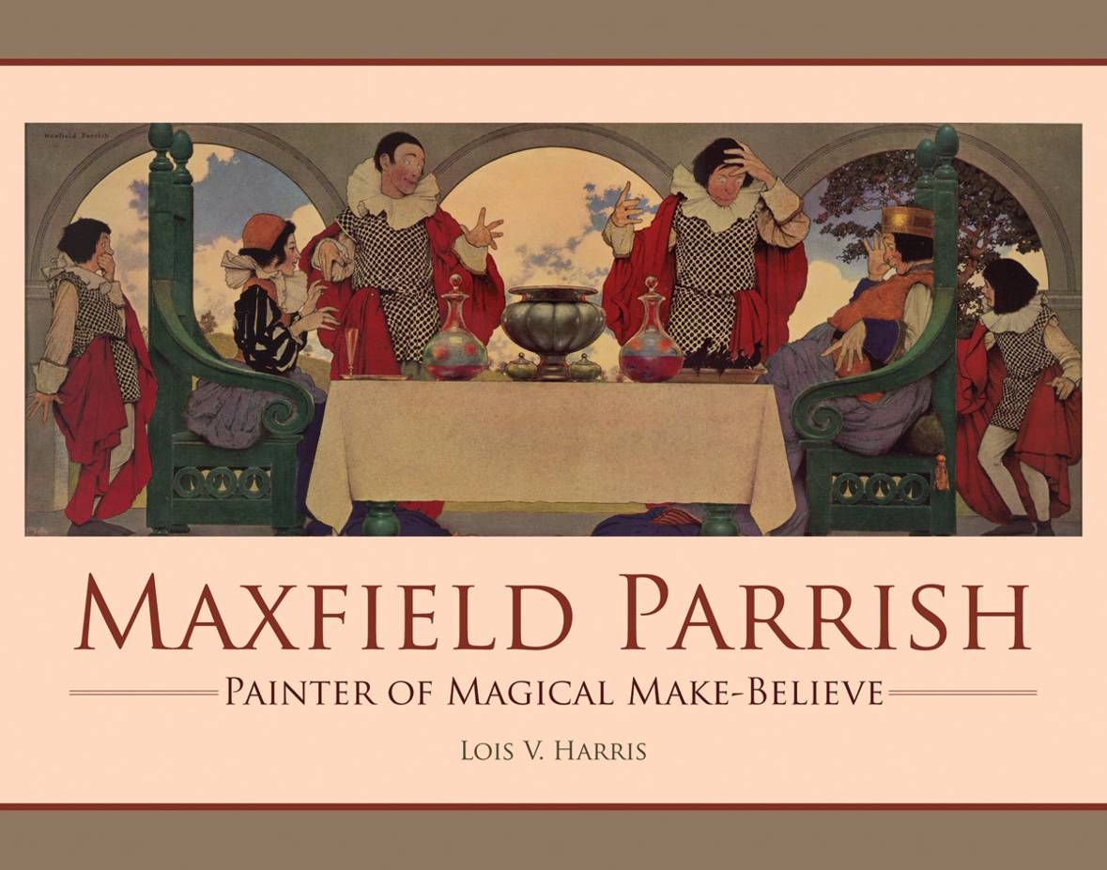
32 pp., 11 x 8½, Ages 5-8, ISBN-13: 9781455614721 $16.99 HC

Maxfield Parrish:
Painter of Magical Make-Believe
BY Lois V. Harris

Guide created by Rebecca Van Slyke
Reproducible worksheets

Discussion Questions
Answer the questions below on a separate piece of paper.

- Fred got a sketchbook for Christmas when he was three. By copying the drawings his father did, he learned to draw. He was an artist! Tell about a present you received that changed your life in some way.
- When Fred and his father visited the Louvre in Paris, they watched artists copy famous paintings in the museum. Why do you think they were copying well-known paintings? Is it okay to copy? What things can you learn from copying? When is it not okay to copy?

- Fred liked to daydream under the copper beech trees. Tell about a place that you like to daydream.

- Fred said that his papa was his best teacher. Tell about something that a parent or someone who takes care of you has taught you.

- When he was an adult, Fred changed his name to “Maxfield.” What new name or nickname would you give to yourself?

- As an adult, Maxfield Parrish returned to the Louvre to study paintings that were hundreds of years old. He said, “What an awesome feeling to be in such a presence.” What do you think he meant by that? Have you ever been close to something very, very old? How did it make you feel?

- Maxfield Parrish entered his designs and illustrations in many poster and magazine contests. What kind of contest would you like to win? (Maybe you have won a contest, and you would like to share that story!)

- There is a saying that “every cloud has a silver lining.” When Maxfield became ill with tuberculosis, a very serious lung disease, he had to paint outside in the cold winter air. That led to him discovering that he loved to work with oil paints. Have you ever had a “cloud,” or an unhappy event, turn out to have a “silver lining?” What good thing came out of it?

- People started calling the deep shade of blue that appeared in many of his paintings, “Parrish blue.” What color would you like to have named after you? Be as specific as you can. (For example, say, “‘Morgan green’ would be the clear green of new leaves in the early spring,” instead of just saying “green.”)

- The paintings and illustrations that Maxfield Parrish did were popular with both children and adults. What is it about his paintings that appealed to children? To adults? To you?

Activities

Creative Writing:
Look at the letter Fred wrote to his cousin Henry (page 7). Write a note like Fred’s illustrated letter. Draw pictures, do fancy lettering and tell one of your relatives or friends what is happening in your life.

Social Studies:
The Parrish family lived in and toured Europe for two years. Read about Europe. What countries make up that continent? What cities or landmarks might you see if you traveled there? Make a list of ten places you would like to visit on your European tour.

Art History:
According to Time magazine, Maxfield Parrish’s prints were as popular as van Gogh’s and Cézanne’s. Look at some paintings done by Vincent van Gogh or Paul Cézanne. Now look at several paintings by Maxfield Parrish. How are they similar? How are they different?

Art:
Some of Maxfield Parrish’s most popular prints were illustrations of fairy tales or nursery rhymes. Think of a favorite story or rhyme and illustrate it. Show it to a friend and ask if they can guess what story your illustration is from.

Art Technique:
When people wondered how Maxfield Parrish made his colors glow, he said he didn’t mix the colors; he layered them. Use crayons and create a picture layering two or more colors to create new, glowing colors. What are some “color equations” you liked? Don’t forget to name your new shades! (Example: Cornflower + Teal + Royal Purple = Icy Ocean)
History & Technology:
Fred was born in 1870. What was happening in the world at that time? Who was the president of the United States? What were some new inventions at that time? Who else was born that year? You can use the internet to find the answers.

Math:
New printing techniques made it easier for people to buy prints of Maxfield Parrish’s work. One magazine sold thousands of his prints for ten cents each. Make a table showing how much money each 1,000 pictures sold for.
# of Prints | Cost
1,000 | $
2,000 | $
3,000 | $
4,000 | $
Do you see a pattern forming? What would 10,000 prints sell for? 20,000? 100,000?

Design:
Look at the Ferry’s Seeds ads on pages 22 and 23. Design a poster advertising a product of your choice using characters from a fairy tale or a nursery rhyme.

Maxfield loved to paint landscapes of his favorite places. Design a calendar showing 12 paintings of your favorite “grand, good place(s) to be in.” (There are many software programs, such as Publisher, or websites that let you print out the dates for the bottom part of a calendar.)

Foreign Language:
Maxfield went to school in Paris, France. Learn to speak some French words. Here are some words to get you started:

Counting Words |  |  | Color Words
English | French |  | English | French
One | Un (uh) |  | Red | Rouge (roozh)
Two | Deux (duh) |  | Orange | 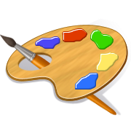  Orange (or-AHNJ)
Three | Trois (twa) |  | Yellow | Jaune (zhon)
Four | Quatre (caht) |  | Green | Vert (ver)
Five | Cinq (sank) |  | Blue | Bleu (bluh)
Six | Six (seess) |  | Purple | Violet (vee-oh-LAY)
Seven | Sept (set) |  | Black | Noir (nwahr)
Eight | Huit (wheat) |  | White | Blanc (blahnc)
Nine | Neuf (nuhf) |  | Brown | Marron (mah-ro)
Ten | Dix (deess) |  | Pink | Rose (rhos)
 |  |  | Gray | Gris (ghree)
Cooking:
After Maxfield finished art school, he crossed the Atlantic Ocean and again visited the Louvre Museum in Paris, France. Have an adult help you make a Croque Monsieur, a popular French sandwich.

Easy Croque Monsieur Sandwiches

Croque Monsieur translates as “Mr. Crunchy.” To make a Croque Madame (“Mrs. Crunchy”), top the broiled sandwich with a fried egg.
Traditionally, these sandwiches are topped with a béchamel sauce. This is an easier version of the classic French sandwich.

Ingredients
For each sandwich, you will need:
2 slices of French bread, toasted
Dijon mustard
2-3 ham slices
Grated gruyère cheese, in two parts

Directions
Toast the bread. Lightly spread mustard on each slice. Add ham and grated cheese, and top with the other slice of toast. Place sandwiches on a cookie sheet and add more grated cheese on top. With an adult’s help, broil the sandwiches for about two minutes, or until cheese is bubbly and golden brown. Watch them carefully so they don’t burn! Remove from oven, cool slightly, and eat.

About the Book
MAXFIELD PARRISH: Painter of Magical Make-Believe
This biography for young readers follows the life of popular American artist Maxfield Parrish, who helped develop the future of visual arts in the United States. A model for future generations, Parrish brought his daydreams to life and shared them with everyone through posters, calendars, murals, advertisements, and illustrated children’s books. Replicas of the artist’s work, including his famous landscapes, accompany his story.

Maxfield Parrish lived an inspiring life. A household name in the 1920s, he was lauded for his style and imagination. People claimed that his colors glowed and Time magazine named him as one of the three most popular print artists in the world. His magical make-believe lands were enjoyed by millions and still hang in collections nationwide.

MAXFIELD PARRISH: Painter of Magical Make-Believe
By Lois V. Harris
JUVENILE NONFICTION / Biography & Autobiography / Art
32 pp. 11 x 8 ½ 1 color photo 9 b/w photos 19 color illus. 3 b/w illus.
ISBN: 9781455614721 $16.99

